Lab 8

Kent Codding

2023-11-10

# install dependencies

library(glmmTMB)

## Warning: package 'glmmTMB' was built under R version 4.1.3

## Warning in checkDepPackageVersion(dep_pkg = "TMB"): Package version inconsistency detected.  
## glmmTMB was built with TMB version 1.9.3  
## Current TMB version is 1.9.6  
## Please re-install glmmTMB from source or restore original 'TMB' package (see '?reinstalling' for more information)

library(performance)  
library(magrittr)

# Step 1

df <- read.csv("RCW_nests.csv")

## remove observations

cluster.counts <- table(df$Cluster)  
viable.clusters <- subset(cluster.counts, cluster.counts >= 5) #subset the table to only include clusters with 5 or more observations  
df <- subset(df, df$Cluster %in% names(viable.clusters)) #subset df to only include clusters within the subsetted table  
df <- subset(df, df$Adults != 6) #remove observations where 6 adults exist

# Step 2

y <- cbind(df$hatched_eggs, df$failed_eggs)

## GLM

mod.glm <- glm(y ~ df$Constructor + df$Adults + df$Adults * df$Constructor + df$Year,  
 family = "binomial")  
summary(mod.glm)

##   
## Call:  
## glm(formula = y ~ df$Constructor + df$Adults + df$Adults * df$Constructor +   
## df$Year, family = "binomial")  
##   
## Deviance Residuals:   
## Min 1Q Median 3Q Max   
## -3.4073 -0.5843 0.1208 1.3119 1.9557   
##   
## Coefficients:  
## Estimate Std. Error z value Pr(>|z|)   
## (Intercept) -22.017345 23.759345 -0.927 0.3541   
## df$ConstructorRCW -0.116218 0.348645 -0.333 0.7389   
## df$Adults 0.189500 0.091891 2.062 0.0392 *  
## df$Year 0.011099 0.011852 0.936 0.3490   
## df$ConstructorRCW:df$Adults 0.006446 0.115042 0.056 0.9553   
## ---  
## Signif. codes: 0 '***' 0.001 '**' 0.01 '*' 0.05 '.' 0.1 ' ' 1  
##   
## (Dispersion parameter for binomial family taken to be 1)  
##   
## Null deviance: 865.10 on 630 degrees of freedom  
## Residual deviance: 851.36 on 626 degrees of freedom  
## AIC: 1569.4  
##   
## Number of Fisher Scoring iterations: 4

## GLMM with random intercept for Cluster

mod.glmm1 <- glmmTMB(y ~ df$Constructor + df$Adults + df$Adults * df$Constructor + df$Year + (1|df$Cluster),   
 family = "binomial")

## Warning in glmmTMB(y ~ df$Constructor + df$Adults + df$Adults * df$Constructor  
## + : use of the '$' operator in formulas is not recommended

## Warning in glmmTMB(y ~ df$Constructor + df$Adults + df$Adults * df$Constructor  
## + : use of the 'data' argument is recommended

summary(mod.glmm1)

## Family: binomial ( logit )  
## Formula:   
## y ~ df$Constructor + df$Adults + df$Adults * df$Constructor +   
## df$Year + (1 | df$Cluster)  
##   
## AIC BIC logLik deviance df.resid   
## 1567.0 1593.7 -777.5 1555.0 625   
##   
## Random effects:  
##   
## Conditional model:  
## Groups Name Variance Std.Dev.  
## df$Cluster (Intercept) 0.05683 0.2384   
## Number of obs: 631, groups: df$Cluster, 68  
##   
## Conditional model:  
## Estimate Std. Error z value Pr(>|z|)   
## (Intercept) -19.377531 24.437799 -0.793 0.4278   
## df$ConstructorRCW -0.157576 0.363135 -0.434 0.6643   
## df$Adults 0.172818 0.096492 1.791 0.0733 .  
## df$Year 0.009811 0.012191 0.805 0.4210   
## df$ConstructorRCW:df$Adults 0.024481 0.119750 0.204 0.8380   
## ---  
## Signif. codes: 0 '***' 0.001 '**' 0.01 '*' 0.05 '.' 0.1 ' ' 1

## GLMM with random slope

referring to the effect of number of adults on hatching within each cluster

mod.glmm2 <- glmmTMB(y ~ df$Constructor + df$Adults + df$Adults * df$Constructor + df$Year +(df$Adults|df$Cluster),   
 family = "binomial")

## Warning in glmmTMB(y ~ df$Constructor + df$Adults + df$Adults * df$Constructor  
## + : use of the '$' operator in formulas is not recommended

## Warning in glmmTMB(y ~ df$Constructor + df$Adults + df$Adults * df$Constructor  
## + : use of the 'data' argument is recommended

summary(mod.glmm2)

## Family: binomial ( logit )  
## Formula:   
## y ~ df$Constructor + df$Adults + df$Adults * df$Constructor +   
## df$Year + (df$Adults | df$Cluster)  
##   
## AIC BIC logLik deviance df.resid   
## 1570.6 1606.2 -777.3 1554.6 623   
##   
## Random effects:  
##   
## Conditional model:  
## Groups Name Variance Std.Dev. Corr   
## df$Cluster (Intercept) 0.26829 0.5180   
## df$Adults 0.01813 0.1347 -0.90   
## Number of obs: 631, groups: df$Cluster, 68  
##   
## Conditional model:  
## Estimate Std. Error z value Pr(>|z|)   
## (Intercept) -20.19126 24.62691 -0.820 0.4123   
## df$ConstructorRCW -0.14630 0.37338 -0.392 0.6952   
## df$Adults 0.17082 0.09884 1.728 0.0839 .  
## df$Year 0.01022 0.01229 0.832 0.4054   
## df$ConstructorRCW:df$Adults 0.02070 0.12291 0.168 0.8662   
## ---  
## Signif. codes: 0 '***' 0.001 '**' 0.01 '*' 0.05 '.' 0.1 ' ' 1

## Compare with AIC

AIC(mod.glm, mod.glmm1, mod.glmm2)

## df AIC  
## mod.glm 5 1569.415  
## mod.glmm1 6 1567.008  
## mod.glmm2 8 1570.610

the lowest AIC for glmm1, the glmm with a random intercept for cluster, is the best model according to this test.

# Step 3

##model selection on fixed terms

summary(mod.glmm1)

## Family: binomial ( logit )  
## Formula:   
## y ~ df$Constructor + df$Adults + df$Adults * df$Constructor +   
## df$Year + (1 | df$Cluster)  
##   
## AIC BIC logLik deviance df.resid   
## 1567.0 1593.7 -777.5 1555.0 625   
##   
## Random effects:  
##   
## Conditional model:  
## Groups Name Variance Std.Dev.  
## df$Cluster (Intercept) 0.05683 0.2384   
## Number of obs: 631, groups: df$Cluster, 68  
##   
## Conditional model:  
## Estimate Std. Error z value Pr(>|z|)   
## (Intercept) -19.377531 24.437799 -0.793 0.4278   
## df$ConstructorRCW -0.157576 0.363135 -0.434 0.6643   
## df$Adults 0.172818 0.096492 1.791 0.0733 .  
## df$Year 0.009811 0.012191 0.805 0.4210   
## df$ConstructorRCW:df$Adults 0.024481 0.119750 0.204 0.8380   
## ---  
## Signif. codes: 0 '***' 0.001 '**' 0.01 '*' 0.05 '.' 0.1 ' ' 1

drop1(mod.glmm1, test = "Chisq") %>% suppressWarnings() # make R shut up about warnings :]

## Single term deletions  
##   
## Model:  
## y ~ df$Constructor + df$Adults + df$Adults * df$Constructor +   
## df$Year + (1 | df$Cluster)  
## Df AIC LRT Pr(>Chi)  
## <none> 1567.0   
## df$Year 1 1565.7 0.64699 0.4212  
## df$Constructor:df$Adults 1 1565.0 0.04179 0.8380

### refit dropping the interaction between constructor and adults

mod.2 <- glmmTMB(y ~ df$Constructor + df$Adults + df$Year + (1|df$Cluster),   
 family = "binomial") %>% suppressWarnings()  
summary(mod.2)

## Family: binomial ( logit )  
## Formula: y ~ df$Constructor + df$Adults + df$Year + (1 | df$Cluster)  
##   
## AIC BIC logLik deviance df.resid   
## 1565.0 1587.3 -777.5 1555.0 626   
##   
## Random effects:  
##   
## Conditional model:  
## Groups Name Variance Std.Dev.  
## df$Cluster (Intercept) 0.05635 0.2374   
## Number of obs: 631, groups: df$Cluster, 68  
##   
## Conditional model:  
## Estimate Std. Error z value Pr(>|z|)   
## (Intercept) -19.039543 24.376033 -0.781 0.43476   
## df$ConstructorRCW -0.086460 0.103929 -0.832 0.40546   
## df$Adults 0.188615 0.057845 3.261 0.00111 **  
## df$Year 0.009619 0.012152 0.792 0.42861   
## ---  
## Signif. codes: 0 '***' 0.001 '**' 0.01 '*' 0.05 '.' 0.1 ' ' 1

drop1(mod.2, test = "Chisq") %>% suppressWarnings()

## Single term deletions  
##   
## Model:  
## y ~ df$Constructor + df$Adults + df$Year + (1 | df$Cluster)  
## Df AIC LRT Pr(>Chi)   
## <none> 1565.0   
## df$Constructor 1 1563.7 0.6891 0.406478   
## df$Adults 1 1573.7 10.6793 0.001083 **  
## df$Year 1 1563.7 0.6259 0.428864   
## ---  
## Signif. codes: 0 '***' 0.001 '**' 0.01 '*' 0.05 '.' 0.1 ' ' 1

### refit dropping year

mod.3 <- update(mod.2, .~. -df$Year) %>% suppressWarnings()  
summary(mod.3)

## Family: binomial ( logit )  
## Formula: y ~ df$Constructor + df$Adults + (1 | df$Cluster)  
##   
## AIC BIC logLik deviance df.resid   
## 1563.7 1581.5 -777.8 1555.7 627   
##   
## Random effects:  
##   
## Conditional model:  
## Groups Name Variance Std.Dev.  
## df$Cluster (Intercept) 0.05803 0.2409   
## Number of obs: 631, groups: df$Cluster, 68  
##   
## Conditional model:  
## Estimate Std. Error z value Pr(>|z|)   
## (Intercept) 0.25516 0.18690 1.365 0.17217   
## df$ConstructorRCW -0.07291 0.10276 -0.709 0.47802   
## df$Adults 0.18637 0.05782 3.223 0.00127 **  
## ---  
## Signif. codes: 0 '***' 0.001 '**' 0.01 '*' 0.05 '.' 0.1 ' ' 1

drop1(mod.3, test = "Chisq") %>% suppressWarnings()

## Single term deletions  
##   
## Model:  
## y ~ df$Constructor + df$Adults + (1 | df$Cluster)  
## Df AIC LRT Pr(>Chi)   
## <none> 1563.7   
## df$Constructor 1 1562.2 0.5016 0.478808   
## df$Adults 1 1572.1 10.4411 0.001232 **  
## ---  
## Signif. codes: 0 '***' 0.001 '**' 0.01 '*' 0.05 '.' 0.1 ' ' 1

### refit dropping constructor

mod.4 <- update(mod.3, .~. -df$Constructor) %>% suppressWarnings()  
summary(mod.4)

## Family: binomial ( logit )  
## Formula: y ~ df$Adults + (1 | df$Cluster)  
##   
## AIC BIC logLik deviance df.resid   
## 1562.2 1575.5 -778.1 1556.2 628   
##   
## Random effects:  
##   
## Conditional model:  
## Groups Name Variance Std.Dev.  
## df$Cluster (Intercept) 0.06035 0.2457   
## Number of obs: 631, groups: df$Cluster, 68  
##   
## Conditional model:  
## Estimate Std. Error z value Pr(>|z|)   
## (Intercept) 0.21469 0.17821 1.205 0.22834   
## df$Adults 0.18591 0.05792 3.210 0.00133 **  
## ---  
## Signif. codes: 0 '***' 0.001 '**' 0.01 '*' 0.05 '.' 0.1 ' ' 1

### Final interpretation

According to drop1 model selection with a chi square test, number of adults in the breeding group is the most important and only significant variable that determines the probability that an egg will successfully hatch. The positive sign for the estimate indicates that the number of Adults in the breeding group correlates with the number of eggs hatched, suggesting that more hands… or bird feet in this case… make for better work in regards to hatching chicks!

# Step 4

## overdispersion?

check_overdispersion(mod.4) %>% suppressWarnings()

## # Overdispersion test  
##   
## dispersion ratio = 1.001  
## Pearson's Chi-Squared = 628.463  
## p-value = 0.487

## No overdispersion detected.

## nonindependence?

plot(residuals(mod.4))

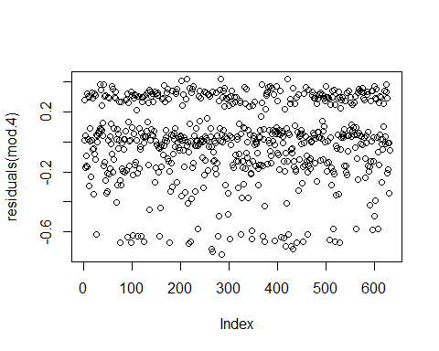

There is evidence of nonindependence based on the above plot of residuals

## random effect normally distributed

coefs <- coefficients(mod.4)  
plot(density(coefs$cond$`df$Cluster`$`(Intercept)`))

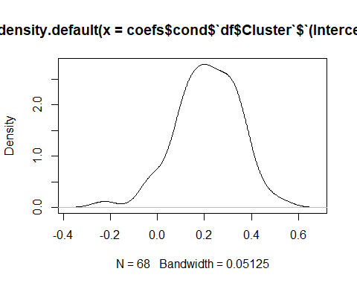 Visually, the random effects of the intercept are drawn from a normal distribution.

## explained variance of hatching success

r2_nakagawa(mod.4) %>% suppressWarnings()

## # R2 for Mixed Models  
##   
## Conditional R2: 0.025  
## Marginal R2: 0.007

only 2.5 percent of variance is explained by the entire model. Additionally, the fixed effects (marginal R2) only explain less than 1 percent of the variance. Thus, the random effects explain 0.025 - 0.007 = 0.018 of the variance.

## Plot

y.pred <- predict(mod.4, type = "response") #predict values as probability of hatching  
df$prob <- df$hatched_eggs/(df$hatched_eggs + df$failed_eggs) # add column to df to represent actual prob of hatching  
  
par(mfrow = c(1,2))  
boxplot(df$prob ~ df$Adults,  
 ylab = "Actual Probability of Hatching",  
 col = "blue",  
 main = "Actual")  
boxplot(y.pred ~ df$Adults,  
 ylab = "Predicted Probability of Hatching",  
 col = "firebrick",  
 main = "Model",  
 ylim = c(0,1))

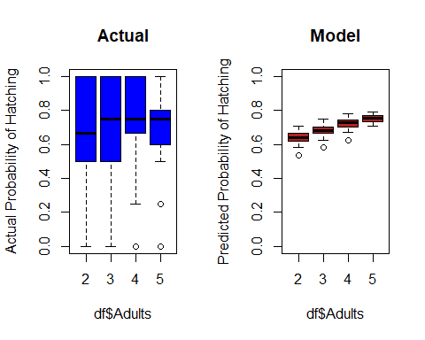

# Step 5

The data suggests that the type of Constructor (RCW vs Human) does not impact the number of hatchlings. Thus, managers should continue creating artificial, human-made cavity boxes in suitable trees. However, given limited resources, managers should focus on creating cavity boxes in suitable trees within areas already populated by large RCW families as the number of adults in each breeding group may affect the probability of eggs hatching.